Emilly Matias-Pereira & Gabriella Cukier
Computational Neuroscience Final Report
Multimodal Image Memorability Prediction: Combining Visual Embeddings, Emotion, & Semantics
1. Introduction
The main question we are investigating is what “sticks” in our minds and what fades away almost immediately. Image memorability is the probability that the person will remember the image after a certain amount of time. Memory scores are gathered from independent observers and are shown to have a strong correlation, implying that memorability influences mainly by image content rather just a individual difference in viewer psychology (Isola et al., 2011).
To discover what makes an image memorable it can be understood in a range from practical to deeply scientific. In advertising, education, and interface designs, doctors goal is to make sure that visuals will help patients retain information that is being presented. Memorability provides a concrete and quantifiable bridge between a low level visual processing, emotional appraisal and long term memory encoding, all of these process are studied in different literatures but are rarely connected through a common task.
Its been proven through computational approaches that deep neural network, specifically that are trained in a large scale image recognition tasks are able to predict memorability scores better than have crafted statistics (Khosla et al., 2015). However, memorability is not just purely a visual phenomena. Studies regarding human memory consistently proved that emotional arousal at encoding strongly improves future recall and recognition. Indicating that the phenomenon is linked to our amygdala-hippocampus coordination during consolidation (Cahill & McGaugh, 1995; LaBar & Cabeza, 2006). Its worth noting, that the semantics richness and the ease that an image can be verbally described has been proposed as a possible contributor to memorability (Isola et al., 2011; Bainbridge et al., 2013).
We are motivated by this array of evidence, this project investigated whether combining visual features with an emotion derived and semantic signals systematically improved memorability prediction, and whether a more complex non-linear architecture will add value beyond just a simple linear readout.
The feature extraction pipeline created:
- High dimensional visual embeddings from CLIP ViT-L/14 and DINO-ViT
- Discrete emotion category scores and a valence/arousal estimates for each image
- Semantic caption embeddings from the BLIP-2 captions that were encoded with Sentence-BERT
By systematically removing and combining the different modalities across with linear regression and MLP architectures, we addressed three main questions:
- How much is memorability explained solely by visual features
- Does emotions and semantic features provide an independent signal beyond just vision
- Is non-linearity a factor, and if so which feature sets?
2. Methods
We utilized LaMem dataset (Khosla et al., 2015) which included continuous memorability scores for approximately 58,000 images that were collected from a large scale crowd sourced memory game. This dataset was derived from a continuous recognition paradigm, each image was associated with a continuous score [0,1] that reflected the fraction of participants that were able to correctly recognize images after a delay filled distractor images. Approximately 16000 images for which all the feature modalities were successfully extracted and retained for the model development. The dataset was divided into three groups: 70% training, 15% validation and 15% test splits, that were stratified to preserve memorability score distribution.
Feature extraction
Four feature modalities were gathered for each of the images:
- CLIP ViT-L/14 visual embeddings (768-dimensional): Images were encoded with CLIP ViT-L/14 model (Radford et al., 2021). The features were L2-normalized and stored as NumPy arrays, the purpose was to provide a main visual backbone and as a reference for our baseline.
- DINO ViT visual embeddings (1024-dimensional): Is a complementary self-supervised visual features from DINO-pretrained ViT (Caron et al., 2021) with the purpose to identify whether a different visual representation provides an additive signal
- Emotion features: Five discrete emotion category scores were computed utilizing the CLIP-based approach. For each of the categories (amusement, excitement, awe, contentment, sadness), a prompt was constructed (ex. "a photo that conveys awe"), was encoded by utilizing the CLIP text encoder, and compared the image embedding via its cosine similarity. The dominant emotion label was identified for each. Also, the continuous valence and arousal scores were calculated from the NRC VAD lexicon that was mapped onto the caption text, which ultimately provided a 2-dimensional affective grounding.
- Semantic text embeddings (384-dimensional): The descriptive captions were generated for each of the images using BLIP-2 (Li et al., 2023). The captions were encoded into dense semantic embeddings by using Sentence-BERT (Reimers & Gurevych, 2019), that produced a descriptive semantic summary of the images content.
The features itself were stored in a parquet format with the raw embeddings in order to avoid a redundant re-computation across the model training runs.
Models
We trained 8 feature configurations across two different architectures:
- Linear regression: A connected linear layer that mapped the concatenated feature vector to a scalar memorability score. It was trained with MSE less, Adam optimizer (lr = 1×10⁻³, weight decay = 1×10⁻⁴).
- Shallow MLP: Is a 3 layer MLP input (input → 512 → 256 → 1) that has ReLU activations, batch normalizations, and drop out (p = 0.3).
The model performance was assessed by using Pearson correlation between predicted and ground truth memorability score and MSE. The pairwise improvements for ViT-only baseline was tested for significance by using Wilcoxon signed rank tests with Bonferroni correction between all four configurations.
3. Results
Linear model Comparison
Table 1 summarizes the performance for all eight feature configurations using the linear regression.

Model | Description | Input Dim | Test MSE | Test r | Δr vs. Baseline
A – ViT only | Baseline | 768 | 0.00604 | 0.6945 | —
B – DINO only | DINO embeddings only | 1024 | 0.00702 | 0.6326 | −0.0619
C – ViT + Emo | ViT + emotion scores | 773 | 0.00589 | 0.7035 | +0.0090
D – ViT + Emo + VA | ViT + emotions + valence/arousal | 775 | 0.00582 | 0.7079 | +0.0133
E – ViT + SBERT | ViT + SBERT text embeddings | 1152 | 0.00581 | 0.7082 | +0.0137
F – ViT Full | ViT + emotions + VA + SBERT | 1159 | 0.00581 | 0.7085 | +0.0140
G – ViT + DINO | ViT + DINO visual fusion | 1792 | 0.00607 | 0.6953 | +0.0008
H – Kitchen Sink | ViT + DINO + emotions + VA + SBERT | 2183 | 0.00578 | 0.7105 | +0.0160
Table 1. Linear model test-set performance for all eight feature configurations. Δr is computed relative to the ViT-only baseline (Model A).
Adding emotion category scores (Model C) showed improvement in r to 0.7035 (+0.009 vs. baseline), and added valence/arousal (Model D) that yielded r = 0.7079. By substituting the emotion features with SBERT semantic embeddings (Model E) showed nearly identical gains (r = 0.7082). The complete model that combined ViT + emotion + valence/arousal + SBERT (Model F) reached r = 0.7085. Adding DINO to the ViT backbone with no other features (ex. Model G) allowed for some improvement (+0.0008), while the kitchen-sink model (Model H) achieved the highest r = 0.7105, but only outperformed slight Model F despite having a 2× larger input dimension.
Scatter Plots & Prediction Quality
Figure 2 shows scatter plots of predicted vs. ground-truth memorability scores for selected models. The graph confirms that predictions cluster closer around the diagonal for high-memorability images, while the low-memorability images showed a greater variance. This shows a pattern thats consistent with a ceiling effect in the memorability score distribution and with the observation that extremely memorable images tend to share a stereotyped visual features (ex. faces, saturated color, central subjects).
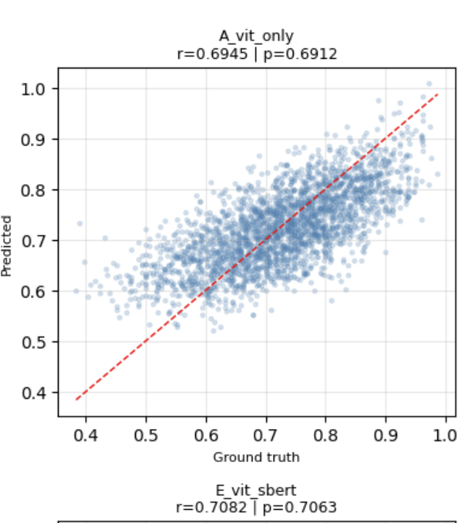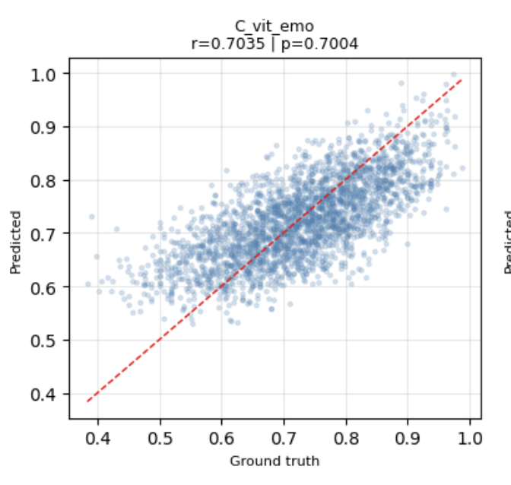

Figure 2. Scatter plots of predicted vs. ground-truth memorability scores for Models A (ViT only) and H (kitchen sink).

Learning Curves
Figure 3 portrays the train and validation MSE learning curves for the linear models.
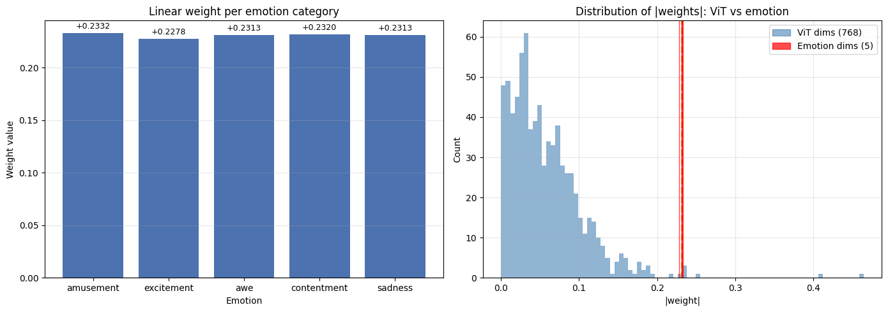
Figure 3. Training and validation MSE learning curves for all eight linear model configurations.
Linear vs. MLP
Figure 4 and Table 2 are comparing linear and the MPL performance across the configurations. The MLP was consistently underperforming relative to the linear model for most of the feature combinations (Δr ranging from −0.008 to −0.456). The largest question was when ViT-only configuration, Model A, which is where the MLP collapsed to r= .239 had a failure mode which is to believed to from the MLP overfit even with dropout and batch normalization. It may be due to the high input dimensionality relative to the training set size. The DINO-only (Model B) and ViT+DINO (Model G) configurations were the only distinct cases where the MLP matched and/or slightly exceeded the linear model, which could be due to the DINO features that have different geometric structures in which local non-linearities tend to be more useful.
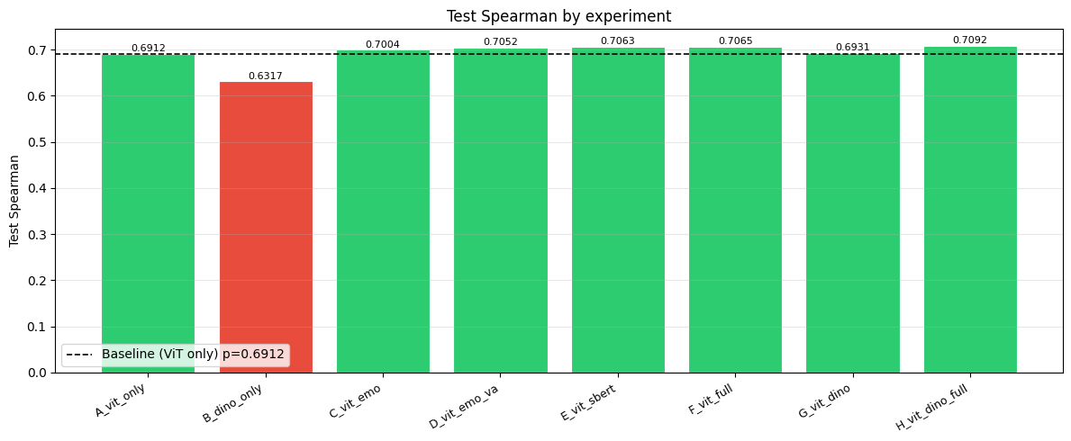
Figure 4. Comparison of Pearson r between linear regression and MLP across all feature configurations.
Model | Input Dim | Linear r | MLP r | Δr (MLP−Lin)
A – ViT only | 768 | 0.6945 | 0.2387 | −0.4559
B – DINO only | 1024 | 0.6326 | 0.6479 | +0.0153
C – ViT + Emo | 773 | 0.7035 | 0.6953 | −0.0082
D – ViT + Emo + VA | 775 | 0.7079 | 0.6912 | −0.0167
E – ViT + SBERT | 1152 | 0.7082 | 0.6695 | −0.0386
F – ViT Full | 1159 | 0.7085 | 0.6861 | −0.0224
G – ViT + DINO | 1792 | 0.6953 | 0.6994 | +0.0042
H – Kitchen Sink | 2183 | 0.7105 | 0.6813 | −0.0293
Table 2. Linear vs. MLP Pearson r. Δr = MLP r − Linear r.
Statistical Significance of Improvements
In order to test whether there was improvements over the ViT-only baselineand if they werestatistically reliable, we conducted Wilcoxon signed-rank tests on per-image squared error differences between each enriched model and the baseline. All four enriched linear configurations (C, D, E, F) showed significant improvements (all p < 10⁻⁹) after Bonferroni correction.

4. Discussion
Results
The main finding of the study is that CLIP ViT-L/14 visual embeddings captured a large portion of what makes an image memorable. With linear readouts having r ≈ 0.69, illuminating consistency with prior work. The fact that performance does not improve with a non-linear MLP is notable: it shows that memorability is encoded approximately linearly in CLIP feature spaces, which is known to encode semantic and perceptual structure (Radford et al., 2021).
Emotion and semantic features contribute to one another in a small but statistically significant and has the capacity to have replicable improvements. The emotion signal is particularly theoretically motivated, since decades of research in cognitive neuroscience showed that emotional arousal at encoding does enhance long term memory. That is mediated by interactions between the amygdala and the hippocampus (Cahill & McGaugh, 1995; LaBar & Cabeza, 2006; Dolcos et al., 2004). The present results consistently showed that images with stronger emotional content (as estimated by CLIP-based emotion scoring) tend to be more memorable, and including emotion features which improved predictions.
The valence and arousal continuous estimates (Model D vs. C) provided another clairity. It aligned with Yerkes-Dodson model of arousal and the dimensional theory of affect (Russell, 1980), “arousal, rather than valence alone, is thought to be the primary driver of memory enhancement”. Thankfully, the emotion weights in the linear model were mostly uniform across the five categories (weights between 0.228–0.233), all which were above the 98th percentile of ViT dimension weights. This almost uniform weighting indicates that the presence of a strong emotion rather than a specific emotion type, is essential in memorability. Which is consistent with neuroscientific accounts that emphasize how arousal is the key dimension. Our finding support that emotion improves memorability prediction computationally proves neuroscience: the basolateral amygdala modulates memory consolidation in the hippocampus in proportion to emotional arousal at encoding, effectively tagging emotionally salient events for preferential storage (McGaugh, 2000).
4.3 Limitations

This is from chat:
There are a few limitations when it comes to interpreting the results. To begin with, the emotion features are estimated by CLIP similarities to the text prompts, meaning that proxy may confuse actual emotional content with the surface visual features associated with the given emotional scene (ex. Human face, outdoor scenes). In future work, it would be ideal to use human rated emotion annotations from a desiccated affect dataset. Furthermore, the MLP results is not the best option when it comes to ViT only configurations due to the hyperparameter sensitivity and/or overfitting issues that weren't fully configured by our current regularization scheme. It would be best to utilize a more systematic hyperparameter search, for example a learning rate, depth, width and drop out could have a stronger MLP performance with these changes. Finally, our study did not distinguish between the different types of memorability relevant content. High memorability could have occurred due to variety of image properties in regards to the different contexts, including face photographs and outdoor landscapes. Naturally from this could have caused the per category analysis to show modality specific effects that were not visible when all the data is lumped together.
4.4 Future Work
There are several branches the research could extend to. One possibility could be to replace the discrete emotion categories with a continuous valence arousal dominance rating on each image and use model trained on human affective ratings. Another could be to fine tune the CLIP or DINO end to nd on memorability prediction tasks besides using the frozen image. This could possibly improve the performance by altering the perspective. There are more expressive architectures like a cross attention fusion over a patch level feature that could possibly improve the multimodal integration besides just a simple concatenation. Finally, the interpretability analysis, possibly incorporate a gradient attrition over the image patches or a concept based explanation could help identify which image region and understand which semantic concepts are the most predictive. This would provide a more direct insight into the computation and neural mechanism of memorability.
Thank you Dr. Schwartz & Dr. Catalan for all your help.
5. References
Bainbridge, W. A., Isola, P., & Oliva, A. (2013). The intrinsic memorability of face photographs. Journal of Experimental Psychology: General, 142(4), 1323–1334.
Cahill, L., & McGaugh, J. L. (1995). A novel demonstration of enhanced memory associated with emotional arousal. Consciousness and Cognition, 4(4), 410–421.
Caron, M., Touvron, H., Misra, I., Jégou, H., Mairal, J., Bojanowski, P., & Joulin, A. (2021). Emerging properties in self-supervised vision transformers. ICCV.
Craik, F. I. M., & Lockhart, R. S. (1972). Levels of processing: A framework for memory research. Journal of Verbal Learning and Verbal Behavior, 11(6), 671–684.
Dolcos, F., LaBar, K. S., & Cabeza, R. (2004). Interaction between the amygdala and the medial temporal lobe memory system predicts better memory for emotional events. Neuron, 42(5), 855–863.
Isola, P., Xiao, J., Torralba, A., & Oliva, A. (2011). What makes an image memorable? CVPR.
Khosla, A., Raju, A. S., Torralba, A., & Oliva, A. (2015). Understanding and predicting image memorability at a large scale. ICCV.
LaBar, K. S., & Cabeza, R. (2006). Cognitive neuroscience of emotional memory. Nature Reviews Neuroscience, 7(1), 54–64.
Li, J., Li, D., Savarese, S., & Hoi, S. (2023). BLIP-2: Bootstrapping language-image pre-training with frozen image encoders and large language models. ICML.
McGaugh, J. L. (2000). Memory — a century of consolidation. Science, 287(5451), 248–251.
Radford, A., Kim, J. W., Hallacy, C., Ramesh, A., Goh, G., Agarwal, S., ... & Sutskever, I. (2021). Learning transferable visual models from natural language supervision. ICML.
Reimers, N., & Gurevych, I. (2019). Sentence-BERT: Sentence embeddings using Siamese BERT-networks. EMNLP.
Russell, J. A. (1980). A circumplex model of affect. Journal of Personality and Social Psychology, 39(6), 1161–1178.

6. AI Tools Statement & Code
AI tools were used in the following ways in this project:
- GitHub Copilot was used as an autocomplete aid during code development (Python pipeline for feature extraction and model training).
- BLIP-2, a generative vision-language model, was used as a component of the feature extraction pipeline to generate image captions, which were subsequently embedded with Sentence-BERT.
- CLIP & DINO models from HuggingFace and OpenAI were used as pre-trained feature extractors and were not fine-tuned

